**ATAR Physics 11**

**Unit 2**

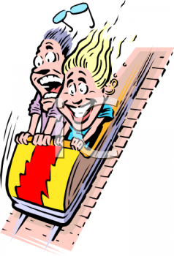

**Linear Motion and Force**

Distinguish between vector and scalar quantities, and add and subtract vectors in two dimensions.

**STRAIGHT LINE MOTION**

**Scalar and Vector quantities**

* In Physics, quantities such as mass, weight, distance, displacement, speed, force, velocity, etc. can be either a scalar or a vector quantity.
* Scalar quantities are those which only have a magnitude (size or value), there is no direction for the quantity to act in. For example, mass, which is simply the amount of matter something has.
* It isn’t appropriate to talk about mass acting in any particular direction.
* Scalar quantities are ones such as *time, mass, distance* and *speed*; they have a magnitude but not a direction in which to act.
* Vector quantities are those that not only have a magnitude, but the direction in which they act is also important.
* If you apply a force on something, it moves in the direction you apply the force, it can’t move in any other direction.
* So vector quantities must have a magnitude and a direction.
* Vector quantities are ones such as *displacement, velocity, acceleration*, *force, work* and of course, *weight.*
* Consider *mass* and the force on mass; *weight*.
* Mass is scalar; it is simply the amount of matter an object has.
* Weight however is that mass acted on by acceleration due to gravity and as gravity always acts downwards – weight is a vector quantity.
* Therefore when giving answers for vector quantities, you must include the direction if it is included in the question.

Distance and displacement

* A student is doing her daily exercise in the park. The distance across the large park is about a kilometre and she runs across the park and back twice. At the end of the exercise she has covered a distance of 4 kilometres and she is back where she started. She is feeling good as she has run 4 kilometres but her friend, who just happens to be a physics student, informs her that as she are right back where you started, her displacement is zero kilometres, so your velocity is zero.

Explanation!

* Distance is scalar, displacement is vector – so although both deal with a starting and finishing position and can be measured in the same units, they must both have a very different meaning in Physics.

**DISTANCE:**

* This is a measure of the total journey from the starting position to the finishing position. So in your case the student ran 4 kilometres across the park.

### Definition: The total path an object travels.

### Units: metres (m) Symbol: distance or dist.

* Example:

If you walk 7.0m, 4.0m, 18m, and 6.0m within the park as shown in the diagram, your distance travelled is the total of the journey.

Start **distance = 7.0 + 4.0 + 18 + 6.0 = 35 m**

6.0m 7.0 m

4.0 m

18 m

## DISPLACEMENT:

## This is the shortest path from where the student started to where she finished.

## She started and finished in the same place so her displacement is zero.

**Definition: Change in position of body (Shortest distance between starting point and**

**finishing point.)**

**Units: metres (m) Symbol: s**

* Example: If you walks 14.0 m east then 10.0 m west, what is your displacement?

origin 14.0 m east **s = 4.00 m East**

4.0 m east 10.0 m west

**PP 6.1 p 174-8 6.1 Review p 179-80** **WSG p84-5**

**MATHEMATICS OF VECTORS**

***NOTE: Vectors in diagrams must be represented by arrows.***

**VECTOR ADDITION**

* Vectors are represented by arrows.
* When adding vectors, the tail of the second is added to the head of the first.
* 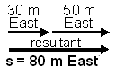The resultant vector is found by drawing a resultant arrow from the tail of the first vector to the head of the final vector.

* Example 1: Jenny runs 30 m east, stops then runs 50 m east.

What was her displacement?

**s = 80 m East**

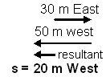

* Example 2: Jack walks 30 m east to meet Jill, they then walk

50 m west to go home. What was Jack’s displacement?

**s = 20 m West**

* Example 3: George walks his dog 30 m north then 40 m east.

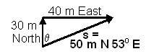 What was his displacement?

s =  θ = tan-1 (40 ÷ 30)

s = 50 m θ = 530

**s = 50 m N 530 E**

* Example 4: Sam rides to the shop 2.0 km south, visits a friend 4.0 km west, walks to the park 4.0 km north, then visits another friend 1.0 km east where he stays the night. Calculate (a) the distance travelled and (b) his displacement from home.

1. distance is total journey = 2.0 + 4.0 + 4.0 + 1.0 = 11.0 km = 1.1 x 104 m
2. displacement from home is the shortest distance

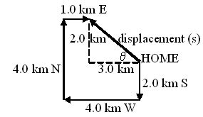s = 

s = 3.6 km = 3.6 x 103 m

θ = tan-1 (2.0 ÷ 3.0)

* = 340

s = 3.6 x 103 m W 340 N

* You are meeting a friend for coffee in town and have travelled there by bus. You get off the bus and walk 35 m east to the corner then 50 m north to the coffee shop. What would your displacement have been if you had been able to travel directly to the shop and not around the buildings in town?

**PP 6.2 p 181-5 6.2 Review p 186**

* Problems on vector addition:
  + - 1. You are on your way to your physics class. You walk 20.0 m west where you meet your lab partner so you both then continue to walk 30.0 m west to the class. What was your distance travelled and displacement?
      2. Fern is a ginger cat who has seen a mouse. She quietly stalks a mouse 2.50 m north when the mouse sees her. The mouse, which is trapped in a corner, runs south passed Fern. Fern turns and runs 3.20 m south where the mouse escapes behind a cupboard. What was Fern’s distance and displacement travelled?

*.*

* + - 1. Kira the dogwalks 2.00 m west to her bowl to have a drink then walks 9.00 m south to her bed to sleep. Calculate the distance that Kira walked and Kira’s displacement.

VECTOR SUBSTRACTION

* When subtracting vectors, you add the opposite vector.

(NOTE: Δ is delta and means change in. The change in anything is final subtract initial. )

* Example1.

Samantha walks at 5.00 ms-1 west then turns to walk at 3.00 ms-1 east what was Samantha’s change in velocity?

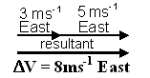

Δv = Final velocity – Initial velocity

= 3 ms-1 East - 5 ms-1 West *is the same as*

= 3 ms-1 East + (-5 ms-1 West) *the opposite of 5 ms-1 West is 5 ms-1 East*

= 3 ms-1 East + 5 ms-1 East

**sΔv = 8.00 ms-1 East**

* Example 2:

Samantha now walks at 5.00 ms-1 east then at 3.00 ms-1 east what was her change in velocity?

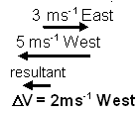

Δv = Final velocity – Initial velocity

= 3 ms-1 East - 5 ms-1 East *is the same as*

= 3 ms-1 East + (-5 ms-1 East) *the opposite of 5ms-1 East is 5ms-1 West*

= 3 ms-1 East + 5 ms-1 West

**Δv = 2.00 ms-1 West**

* 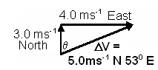Example 3: A bike is travelling 4.0 ms-1 west, it then turns a corner to travel 3.0 ms-1 north which it does in 2.0 s. What is the change in velocity?

Δv = Final velocity - Initial velocity

= 3.0 ms-1 North - 4.0 ms-1 West *is the same as*

= 3.0 ms-1 North + (-4.0 ms-1 West) *the opposite of*

*4 ms-1 West is 4ms-1 East*

= 3.0 ms-1 North + 4.0 ms-1 East

Δv =  to find angle, θ = tan-1 (4.0 ÷ 3.0)

Δv = 5.0 ms-1 = 530

Then final answer has ΔV, final velocity direction, value of angle, initial velocity direction.

**Δv = 5.0 ms-1 N 530 E**

* **NOTE**: Using time, you can find the acceleration around the corner as acceleration is the change in velocity divided by time.

**note**: ΔV = (v – u) which is NOT (3 - 4 ) as the direction has changed. Don’t make this



common mistake.

a = 2.5 ms-2 N 530 E

*(Acceleration is a vector quantity so must also have a direction)*

* A car travelling around a corner is travelling initially at 10 ms-1 north then after the corner the car is travelling at 20 ms-1 east. If this takes 1.5 s, determine the car’s acceleration around the corner.

**PP 6.3 p 187-91 6.3 Review p 192**

Problems on vector subtraction:

1. While exercising in the park you are running along at 1.50 ms-1 east when you need to pass another runner so you slow down to 1.20 ms-1 east. What was your change in velocity?
2. A toy walking robot will reverse direction whenever it hits an object. The robot is walking at 0.400 ms-1 north when it hits a wall and reverses to walk 0.200 ms-1 south. What was the robots change in velocity?
3. A cyclist in a race is travelling at 5.00 ms-1 east when he rounds a corner to then be travelling at 6.00 ms-1 south.
   1. What was his change in velocity?

* 1. What was his acceleration around the corner if the change in velocity took 2.50 s?

**PP Chapter review p 196**

**WSG p89-92**

Uniformly accelerated motion is described in terms of relationships between measurable scalar and vector quantities, including displacement, speed, velocity and acceleration.

*This includes applying the relationships*



##### **SPEED, VELOCITY AND ACCELERATION**

* NOTE: to change kmh-1 to ms-1 and back again.

*kmh-1 to ms-1 divide by 3.6*

*ms-1 to kmh-1 multiply by 3.6 Easy isn’t it!*

**Speed**

* Consider the student exercising in the park.
* The distance from where she started changed – the rate at which her distance changes is her speed.
* The **instantaneous** speed tells us how fast an object is going at a particular instance in time.
* The **average** speed can be considered as the total distance travelled divided by the total time taken – this will gives average speed for a journey.

**Definition: The rate of change of distance OR Distance travelled divided by time taken**

**Units: metres per second (ms-1) Symbol: speed.**

* Example:

While exercising vigorously, it took you 12 minutes to run 4.0 km, what was your average speed.

distance = 4 000 m speed (ave) = distance = 4000

time, t = 12 x 60 t 720

t = 720 s speed (ave) = 5.6 ms-1

* Speed is a scalar quantity – magnitude only.
* Velocity is a vector quantity and will give not only a magnitude but also a direction.

## Velocity

* Consider the run across the park.
* While her average speed will tell you how fast, on average, she was travelling, her velocity will tell the rate at which her displacement changes and in what direction.

**Average Velocity:**

* This is the total displacement (where she started to where she finished) divided by the time it took.
* Average velocity explains why the exercising in the park produced a zero velocity as her displacement was zero.

**Definition: The rate of change of displacement OR Displacement divided by time taken**

**Units: metres per second (ms-1) Symbol: *v*av for velocity; u for initial velocity and v for final velocity**

* Another way to look at average velocity is to add two known velocities together and divide by 2 as shown on the right.



* Change in velocity is given by Δv = v – u

* Example: You are running across the park from the east towards the west. You have run the first kilometre towards the west then have returned 0.50 km east. If that part of the run took 4.5 minutes, what was your average velocity for that part of the run?

1000 m W

Displacement =



500 m E s = 500 m W

s = 500 m W

t = 4.5 minutes vav = 1.9 ms-1 west

t = 4.5 x 60

t = 270 s

**Instantaneous Velocity**

* It is important to distinguish between instantaneous velocity and average velocity.
* If you pass a speed camera, it is measuring your **instantaneous** velocity, or your velocity at that moment.
* The police are not interested in the fact that your **average** velocity for the total journey was below the speed limit, they are measuring if, at a particular instance in time, you are travelling above the speed limit.
* Example: During your run you travel 30.0 m at 4.60 ms-1 east then for 20.0 m you travel at 6.50 ms-1 east, what was your average velocity over this displacement?



*v*av = 5.55 ms-1 East

**PP 7.1 p 198-205 7.1 Review p 206-7**

* **Questions:**
  + - 1. A car rounding a bend at a constant speed is actually accelerating. How can this be so?
      2. A car changes velocity from 58.0 kmh-1 to 20.0 kmh-1 to avoid hitting a dog. The change in velocity took 4.50 s
         1. Find the car’s acceleration.
         2. Explain why the value is negative.
         3. How much longer will it take the car to stop if it continues to brake at the same rate?

**WSG p86-9**

## Acceleration

* During the exercise session, the student’s instantaneous velocity at any one point can be different to her instantaneous velocity at another point.
* During her run she must have been accelerating and decelerating (which is also negative acceleration).
* Acceleration describes the rate of change of velocity.
* Acceleration is also a vector quantity, so direction must also be considered.

**Definition: The rate of change of velocity. OR Change in velocity divided by time**

**Units: metres per second squared (ms-2) Symbol: a**

where: a = acceleration (ms-2)



u = initial velocity (ms-1)

v = final velocity (ms-1)

t = seconds (s)

also v = u + at as an alternative formula.

*NOTE: Positive acceleration is going faster, negative acceleration is slowing down*.

* Example:

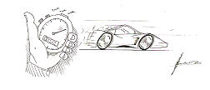The official method to find a car’s acceleration is to find out how quickly it can obtain 60.0 miles per hour from a standing start. Currently, the world’s fastest accelerating car is a Barabus TKR which can go from a shimmering standstill to 60.0 miles per hour (96.56 kmh-1) in only 1.67 seconds. Calculate the car’s acceleration.

u = 0 ms-1



v = 96.56 kmh-1

= 26.82 ms-1

t = 1.67 s



a = 16.1 ms-2

**NOTE**: For all you Top Gear fans, the fastest street legal production car is the Bugatti Veyron (£850,000) which, with its 1001 hp and 10 radiators, can reach a staggering 408.47 kmh-1 (about 253 mph) which is faster than the fastest formula one car (around 230 mph) although not the fastest speed travelled in a car (specially designed rocket cars) which was around 320 mph. Also remember that as James May points out, “the tyres will only last for about fifteen minutes, but it's OK *because the fuel runs out in twelve."*

**PP 7.2 p 208-11 7.2 Review p 212**

**WSG p93-5Distance, Displacement, Speed, Velocity and Acceleration**

1. Edgar Ant was looking for food. His journey to the food is shown below:

Start N

Food W E

S

1. Measure the distances and determine what distance Edgar travelled.
2. Now measure Edgar’s displacement.
3. Elmo is hunting rabbits! Elmo sees Robbie Rabbit in the woods in front of him but to get to Robbie, Elmo must travel 15.0 m west then 7.0 m south around the lake. By the time he gets there, Robbie has gone! If Elmo had simply fired his gun at Robbie, what would the bullet’s displacement have been?

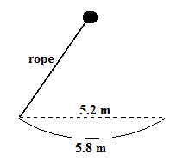

1. Young Billy is swinging on a rope from one platform to another. The platforms are 5.2 m apart but Billy travels 5.8 m as shown. If it took 2.6 s to swing to the second platform,
   1. at what speed did Billy travel at?

* 1. what was Billy’s velocity?

1. Before speed cameras were used to catch speeders, motorists were picked up when they drove over two cables placed 2.70 m apart on the road. One motorist, in a 50.0 kmh-1 zone, took 0.180 s to pass between the two cables. Was he speeding?
2. Dill, Tommy’s little brother, is following Tommy around the back yard. For one particular part of the journey, Dill crawls 3.60 m south then 4.10 m east. If this took 9.80 s,
   1. what was Dill’s speed?
   2. what was Dill’s velocity?
3. Leela the Norwegian Elkhound is walking along at 1.90 ms-1 when she sees the neighbour’s sheep wandering in our yard. She immediately takes off at a run (obviously to herd them back home) at 6.30 ms-1 in the same direction. If the change in velocity took place in 0.900 s, what was Leela’s acceleration?

1. Freddy Frog hops along at 0.6 ms-1 he accelerates at 1.7 ms-2 to reach a final velocity of 1.4 ms-1. How long did it take to reach his final velocity?
2. This morning Fern, the ginger cat, walks into the house with a mouse in her mouth. Fern is then frightened by Kira (the German Shepherd), so drops the mouse which immediately takes off with an acceleration of 0.8 ms-2 to reach a velocity of 1.6 ms-1 in 0.34 s. Assuming that the mouse had an initial velocity equal to that of Fern (well it was in her mouth!) and that the whole journey was in a straight line, what was the initial velocity of the mouse?

Representations, including graphs, vectors, and equations of motion, can be used qualitatively and quantitatively to describe and predict linear motion.

# MOTION GRAPHS *NOTE: Use a ruler for drawing all graphs.*

**Distance/time and Displacement/time**

A distance/time graph shows ______________________

* Exercise:

Consider the following graph of a families’ three hour journey (leave in km, hours and kmh-1)

Describe the journey. ________________________

____________________________________________________________________________________________________________________________________________________________________________

Calculate the speed in each of the three sections of the graph (leave in kmh-1, hours and km)

* section one:
* section two:
* section three:

The problem with a distance/time graph is that it doesn’t show direction of motion. In actual fact, the family travelled to the shopping centre, brought their weekly shopping, and then returned home to put the shopping away. To determine the actual direction something moved, we need a displacement/time graph.

A displacement/time graph shows __________________________ which equals; 

This is shown in the graph below of our families shopping journey.

* Exercise: The car travelled forward in the first hour, stopped to shop for an hour and then travelled back home in the last hour.

Now work out the velocity for each section (leave in

kmh-1, hours and km) East

section one:

section two:

section three:

You can now see that the sign in front of the velocity gives the direction.

Exercise: List the differences between the two graphs of the same journey.

________________________________________________________________________________________________________________________________________________________________________________________________________________________________________________

* Exercise: Alan is practicing for a bicycle race. He starts out from home and rides 50 km east in 4.0 hours; he then travels at a comfortable 20 km east in 3.0 hours, he stops for lunch for 2 hours, then returns to his home in 5 hours.

Draw the graph then calculate the velocity for each section of the graph (leave in kmh-1, hours and km)

______________________________________________________________________________________________________________________________________________________________________________________________________________________________________________________

_________________________________________

Calculate the total distance travelled = _________________________________________________

and the total displacement = _________________________________________________________

Exercise**:**

Consider the following graph which shows the journey of a toy boat on a large pond travelling west.

Describe the journey including the velocities. West

__________________________________________________________________________________________________________________________________________________________________________________________________________________________________________________________________________________________________________________________________

Exercise**:** To determine the acceleration of a car, officials measure how long it takes for the car to get from a standstill to 60 miles per hour (96.56 kmh-1).

Explain why this graph is curved then calculate this car’s acceleration using the values in the question and graph.

________________________________________________________________________________________________________________________________________________________________________________________________________________________________________________________________________________________________________________________________

|  |
| --- |
| Note: To determine if quantity is slope or area under curve then:  slope of quantity = eg.  area under curve = A x B eg. ΔV = Ft |

## Velocity / time Graphs

A velocity/time graph shows ______________________

A truck uniformly accelerates from zero to 16 ms-1 in 4.0 s.

Calculating acceleration:



a = 4 ms-2

The ***displacement*** is the area under the line of the graph.

|  |
| --- |
| s = ut + ½ at2  s = (0 x 4) + ½ x 4x 42  s = 2 x 16  s = 32 m |

area = ½ base x height

area = 0.5 x 4 x 16

area = 32 m

So displacement, s = 32 m

Therefore:

1. acceleration can be calculated by change in velocity over time.
2. the displacement is the area under the line of the graph.
3. the slope of the graph gives acceleration.

Exercise**:** Consider thefollowing graph of a remote controlled toy car and then describe the journey.

The toy car starts from rest with a positive uniform acceleration of _____________ for ____ second. It then continues at a positive constant ___________ of _______________ for ____ s. The car then uniformly accelerates at ____________________ for ______s and is now ________ m from where it started. Finally the car accelerates at _____________ for ____ s at which point it has returned to its starting point.

Exercise**:** Graph the following journey. A car travelling at 20 ms-1 slows to 15 ms-1 in 5 seconds. It then continues its journey for 10 seconds when it increases it velocity to 25 ms-1 in 7 seconds.

Calculate the displacement of the car

**Acceleration/time Graph**

* Year 11 Physics only deals with uniform acceleration.
* All acceleration/time graphs will look like the graph to the right which shows acceleration due to gravity in a frictionless situation.
* Exercise: Briefly describe the motion (qualitatively) for each of the following graphs each of which is the motion of a car.

**Remember the Terminology:**

* upwards is negative or positive, downwards is positive or negative.
* an unchanging velocity value is called a constant velocity;
* an unchanging acceleration value is called a uniform acceleration.
* This is illustrated in the two graphs below
  + - Complete a description for the graphs below.

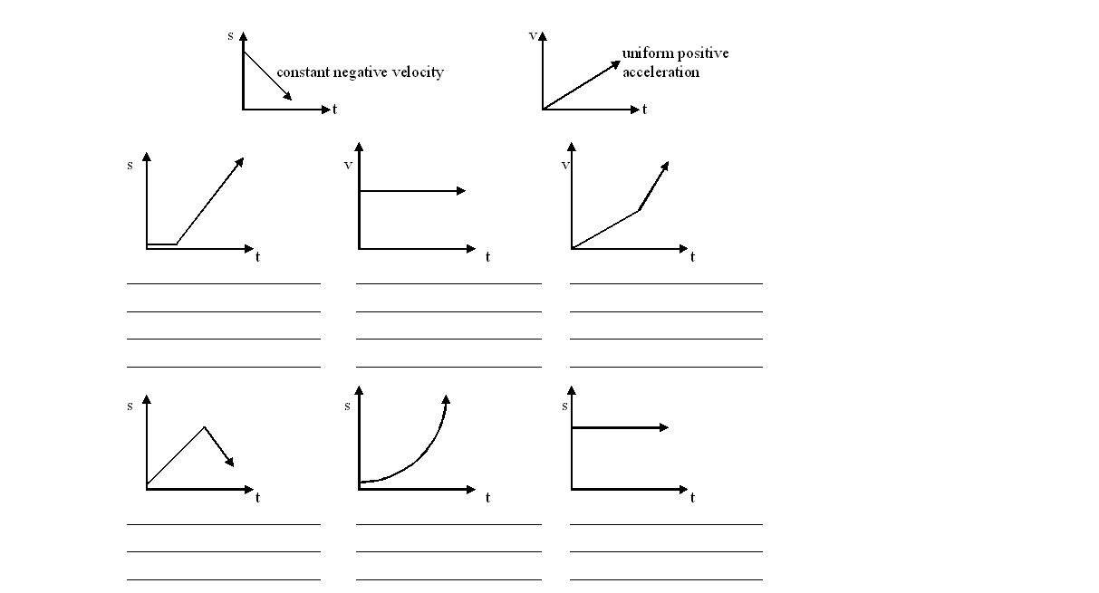

**PP 7.3 p 213-23 7.3 Review p 224-5**

**WSG p96-8**

**THREE EQUATIONS OF MOTION**

* **Equation One:**

Acceleration equals change in velocity divided by time.

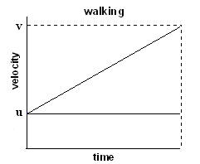 **a =**  **EQUATION ONE**

* **Equation Two:**

A walker out for some exercise, while having an average velocity on the walk, will accelerate at different parts of the walk. Consider one part of the walk where the walker was walking at one velocity then increased to a second velocity. The graph this is shown to the right.

In the graph, the acceleration is the gradient of the graph and we know that acceleration is the rate of change of velocity:

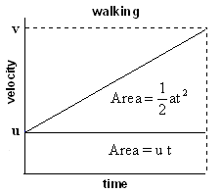 a =  OR (v – u) = at (equation 1)

Also, the displacement is the area under the graph:

Area for rectangle = u t

Area for triangle = ½ base x height

= ½ (v – u) t

and from equation (1) we know that (v – u) = at therefore

Area for triangle = ½ at x t

= ½ at2

So the displacement on the velocity / time graph is the area under the graph, and the second of Newton’s equation of motion can be shown as:

**s = ut + ½ at2 EQUATION TWO**

* **Equation Three:**

If we take a =  then we can re-arrange this to be; t =  (equation 2)

Also you will remember that v(ave) =  (equation 3)

Now vave =  therefore, s = vave  t.

so using s = vave t and substituting equation 2 for vave and equation 3 for t

s =  x 

2as = (v + u) (v – u) = v2 – uv + uv – u2

2as = v2 – u2

or more commonly

**v2 = u2 + 2as EQUATION THREE**

# Steps in solving problems

1. Read the problem three times:
2. to simply get an idea of the area of the problem and generally what it is about.
3. to gain a deeper understanding and to determine concepts and formulas required to solve the problem. (At this stage underline important information.)
4. to get information to draw a simple diagram and get numerical information (steps 2 & 3)
5. Draw a simple diagram of the situation.
6. Neatly write down the information that has been given in the question, using positive and negative values to indicate directions. Convert all units to SI units e.g. m, kg, s, etc.
7. From your understanding of the problem and the data given, select the appropriate equation.
8. Use the appropriate number of significant figures in your answer using scientific notation is necessary.
9. Include units with the answer and specify a direction if the quantity is a vector and directions are given in the question.
10. Re-read the question and
11. check your answer makes sense!!! If you get the mass of a car as 0.1 kg, or the length of a truck as 1.0 x 103 m, something is obviously wrong.
12. ensure you have actually answered the question asked.

* Example:

A car, starting from rest, reaches a velocity of 63.0 kmh-1 in 3.50 s. If the average acceleration was 5.00 ms-2, how far did the car travel?

u = 0 v2 = u2 + 2as OR s = ut + ½ at2

v = 63 kmh-1 17.52 = 0 + (2 x 5 x s) = 0 + ½ x 5 x 3.52

= 17.5 ms-1 306 = 10s s = 30.6 m

a = 5.0 ms-2 s = 306 s = 3.06 x 101 m

t = 3.5s 10

s = ? s = 3.06 x 101 m = 30.6 m

* Activity:

A cat, running at 1.70 ms-1, accelerates at 0.500 ms-2 in a time of 1.20 s to catch a mouse. Calculate the final velocity of Fern.

* Activity:

Captain Courageous is flying through space at 208.8 kmh-1 when he sees space pirates attacking an unarmed spaceship. He accelerates at 15.6 ms-2 for 50.0 m to reach the spaceship. What is his final velocity as he reaches the spaceship?

* Activity:

A family out for the day were travelling along in their car at 60.0 kmh-1. The driver, seeing road works in front of him, accelerates the car at –5.00 ms-2 covering 24.7 m during this time.

1. What is the final velocity in kmh-1? b. How long did it take the car to cover the 24.7 m?

* Activity:

A remote controlled car is travelling at 2.00 ms-1 when it accelerates at 1.80 ms-2 to cover 5.00 m. How long did it take to cover this distance?

* **Questions.**

1. In a sprint race Carl can accelerate from rest to 11.13 ms-1 in 3.25 s. Calculate Carl’s average acceleration.
2. In an attempt on the world land speed record, a rocket car accelerates from an initial velocity to 96.0 ms-1 east in 2.30 s. If the rocket car’s acceleration was 30.0 ms-2, what was its initial velocity?
3. Caroline’s sports car accelerates from zero to 45.0 kmh-1 in 2.65 s in first gear. What is the sports car’s average acceleration?
4. In his motorcycle log book, Adam notes that his motorcycle can accelerate from 21.8 kmh-1 to 28.6 kmh-1 in 1.70s.
   1. What is the magnitude of the acceleration of his motorcycle?
   2. If he maintained this acceleration how much longer would it take to reach 62.6 kmh-1?
5. Vincent’s car has a speed of 12.5 ms-1 when he steps on the accelerator. This accelerates his car at 4.50 ms-2 for 7.00 s. He then applies the brakes that decelerate his car at 11.0 ms-2 till it comes to a rest. All this happens on a straight road. Determine how far he has driven.
6. Jack and Jill are running down the road at 2.60 ms-1. Jill stops at exactly the same time that Jack accelerates for 2.00 seconds to reach a velocity of 3.20 ms-1 when he stops suddenly.
   1. Calculate Jack’s acceleration.
   2. At this point, how far apart are the two children?

* **Problem.**

A cat is out hunting again and this time she is after a cheeky little wren that lives outside the front window. The cat accelerates from where she was sitting to a velocity of 0.800 ms-1 north in 1.00 s. She maintains this velocity for 1.50 s where she accelerates rapidly at 1.35 ms-2 to 3.50 ms-1 north to try to catch the bird. The cheeky wren had already seen the cat and escapes. The cat, in disgust, stops in a rapid 1.00 m to sit and watch the bird fly away.

Draw a displacement/time graph of Fern’s hunt.

|  |  |  |  |  |  |  |  |  |  |  |  |  |
| --- | --- | --- | --- | --- | --- | --- | --- | --- | --- | --- | --- | --- |
|  |  |  |  |  |  |  |  |  |  |  |  |  |
|  |  |  |  |  |  |  |  |  |  |  |  |  |
|  |  |  |  |  |  |  |  |  |  |  |  |  |
|  |  |  |  |  |  |  |  |  |  |  |  |  |
|  |  |  |  |  |  |  |  |  |  |  |  |  |
|  |  |  |  |  |  |  |  |  |  |  |  |  |
|  |  |  |  |  |  |  |  |  |  |  |  |  |

**REACTION TIME AND STOPPING DISTANCE**

* Drivers in cars must often react quickly to situations and brake quickly to avoid an accident. The distance they stop in is composed of two parts: ***reaction time + braking distance***
* **Reaction time:**

This is the distance you cover between seeing a situation and hitting the brakes. If you are concentrating on your driving, if you are not tired, if you are not under the influence of drugs or alcohol, if the roads are dry and the weather is clear, and if your car and tyres are in good condition, this can be as short as 1.50 second (however that is a lot of ifs!!). During this time you are still travelling at 60.0 kmh-1 and you can travel 25.0 m or more before the braking even starts! So during the reaction time as there is no change in acceleration involved, the distance covered during this time can be calculated using *s = vt*.

* **Breaking distance:**

Once the person starts to brake, the car is decelerating and Newton’s Equations of Motion are then used to find the distance travelled or the time over which the braking occurs. Again, if travelling at 60.0 kmh-1 this can still be a distance of 20.0 m or more depending again on road, weather and your car’s condition.

As all of you will be driving a car within 18 months you should consider the following information from the Australian Transport Safety Bureau which is based on more realistic situations than year 11 Physics.

*Let’s assume it’s a dry day, your car’s new and your tyres and brakes are in top nick. You’re driving in a 60 kmh-1 zone when a kid runs onto the road, 45 m ahead. What happens?*

Metres 5 10 15 20 25 30 35 40 45 50 55 60 65

|  |  |  |  |  |  |  |  |  |  |  |  |  |  |  |  |
| --- | --- | --- | --- | --- | --- | --- | --- | --- | --- | --- | --- | --- | --- | --- | --- |
| 50 kmh-1 | **REACTION** | | | | **BREAKING** | | | | | Stop in | | | time | | |
| 60 kmh-1 |  |  |  |  |  |  | | |  |  |  | | Just touch | | |
| 65 kmh-1 |  |  |  |  |  |  |  | |  |  | |  |  | Hit at 32 kmh-1 | |
| 70 kmh-1 |  |  |  |  |  |  | |  | |  |  | |  | | Hit at 46 kmh-1 |

*Have another look at the 65 kmh-1 example. That’s right. Just 5 kmh-1 too fast is the difference between scaring the hell out of the kid (and you), and cleaning him up at 32 kmh-1. And if you’ve ever seen someone who’s been on the wrong end of a tonne and a half of steel, plastic and rubber travelling at ‘only’ 32 kmh-1, then you’ll have some idea of why you don’t speed.*

* Example 1:

A year 12 student, late for school, is travelling at 72.0 kmh-1 in a 60.0 kmh-1 zone. He sees cars braking in front of him and, suspects a speed camera. There is indeed a speed camera and he is 75.0 m in front of it when he knows he needs to brake. His reaction time is 0.50 s and he decelerates at 3.50 ms-2. The camera can read his speed when he is 40.0 m from it. Will he be booked?

**PP 7.4 p 226-9 7.4 Review p 230-1**

Vertical motion is analysed by assuming the acceleration due to gravity is constant near Earth’s surface.

**FALLING BODIES OR ACCELERATION DUE TO GRAVITY**

* Consider the situation when a ball is thrown into the air and then returns to the same height from which it is thrown.
* Fill in the values below to show your understanding of velocity and acceleration at different points of the journey, your teacher will check your answer.

*Using direction to show vector Using positive and negative numbers to*

*show direction, down is positive*

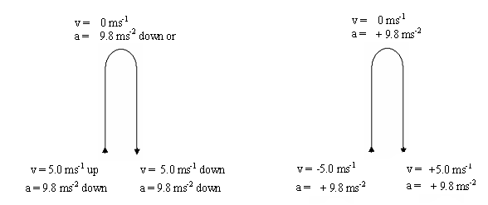

* Neglecting air resistance, all objects fall at the same rate, *regardless of their mass.*
* This was clearly demonstrated on one of the moon landings when a feather and a rock were dropped and landed on the surface at the same time.
* The motion of the objects was only affected by gravity – which is constant.
* On Earth the acceleration due to gravity is approximately 9.8 ms-2. This is shown below where an object gains or looses 9.8 ms-1 every second.

**time velocity**

In reality, when an object falls, terminal velocity is quickly reached and a constant velocity for the fall obtained as the downwards acceleration equals the upwards force of air resistance.

gravity

air resistance

0

1s

9.8 ms-1

2s

19.6 ms-1

OR

3s

10.4 ms-1

2s

20.2 ms-1

1s

30 ms-1

* As acceleration due to gravity is a uniform acceleration, we can use Newton’s equations of motion in solving problem.
* Instead of ‘a’, we use ‘g’ to represent acceleration due to gravity.
* In addition, direction now becomes important (for up and down problems) and must be specified.
* Designate one direction as positive and one

|  |
| --- |
| where:  g = acceleration due to gravity (ms-2)  s = displacement (s)  u = initial velocity (ms-1)  v = final velocity (ms-1)  t = time (s) |

**Formulas now become:**

v = u + gt

s = ut + ½ gt2

v2 = u2 + 2gs

* Example 1:

Two children are dropping stones from a bridge to the water below to try and hit the leaves floating by. If one child holds a stone 15.0 m above the water, calculate

1. how long before the stone hits the water.
2. the final velocity of the stone just as it hits the water.

* Example 2:

A ball is thrown up into the air at 12.0 ms-1. How long was it in the air if it was caught at the height it was thrown from?

* Example 3:

In a dive, a competitor springs 1.70 m into the air, turns and dives into the water below. If the diving board is 10.0 m above the water, and the initial velocity of the diver is 5.77 ms-1, how long is the diver in the air?

**PP 7.5 p 232-6 7.5 Review p 237-8 Chap Review p 239-41**

**WSGp99-102 Review Q’s 1-15 p124-5**